The Middlefield Fair:
A Case Study of the Agricultural Fair in New England
(Nineteenth Century)

Senior Honors Project
Erin Judge

History
December, 2010
Westfield State University

Prepared to fulfill the requirements
for Commonwealth Honors Scholar

Honors Project Committee:
Mara Dodge, Ph.D., History, Project Advisor
Margot Hennessy, Ph.D., Ethnic and Gender Studies, Department Reader
Ricki Kantrowitz, Ph.D., Psychology, Honors Program Reader

Introduction

If one were to visit the Middlefield Fairgrounds on nearly any day of the year, one would encounter an almost haunting sight. The old buildings stand on what is one of the highest points in town and the wind is a near-constant presence, sweeping around the buildings and blowing the leaves and debris in quick gusts. Bare patches of rock are exposed beneath the grass, revealing the fact that the whole area sits on a massive boulder. These old buildings each have a unique character and none of them stand entirely straight anymore. Their white paint is flaking and the loose sections of the metal roofs are sometimes caught in the wind making a loud clanging sound. The main exhibit hall has stood on this peak against the wind and harsh New England winters for over 150 years now.
But for at least one weekend a year, the fairground comes to life and with it the sleepy little town of Middlefield. For most of the year, this rural Massachusetts town in the foothills of the Berkshires is quiet and isolated. Middlefield has a population of only 500 people and has almost no local economy; even the general store has been closed for several years now. The children of Middlefield attend elementary school in the neighboring town of Chester, and then go to the regional middle and high school in Huntington along with students from six other towns. The town center is inconceivably small to many. There is the now empty general store, the Congregational Church, fire station, senior center and a cluster of about twenty houses. It is easy for a traveler to drive through Middlefield without even noticing it. But if one takes the time to look there is a rich history waiting to be told. Although the landscape is nearly covered in forest today, the stone walls which seem to line every road and crisscross the countryside are a testament to the settlers who opened this land for farming. Old photographs show a landscape almost devoid of trees and reveal the extent of agriculture that once existed. In 1836 there were 9,678 sheep sheared in Middlefield. In fact, the town was only exceeded in sheep by the nearby towns of Hinsdale and Lanesboro. Middlefield was also known for its high quality cattle.
Once a year, in the second weekend of August, Middlefield celebrates this history as the Highland Agricultural Society carries on the tradition of the Middlefield Fair. The fair is a relic of the past; it is a reminder of the days when the town was a thriving agricultural center. The fairground itself embodies the character of the town; old and worn, yet determined to carry on and unwilling to fade away. And the history of the Middlefield Fair provides a window through which one can view rural life in Massachusetts.
The agricultural fair’s original purpose was for agricultural education, and yet it became so much more. Entertainment took on a growing role as fairs developed and its role often sparked debate as to the proper function of the fair. Through a historical analysis of the fair one can learn about the interaction between rural men and women, as well as the role of social class in the leadership of the agricultural societies which ran the fairs. It is through these various aspects of the fair that one can gain an understanding of rural society in places such as Middlefield, Massachusetts.

The Rise of Agricultural Fairs

The agricultural fair is a uniquely American institution, but it has its roots in the European tradition of fairs. According to the Oxford English Dictionary, a fair was a “periodical gathering of buyers and sellers, in a place and at a time ordained by charter or statue or by ancient custom.” Fairs have existed from the early days of human society and seem to have originally held a religious significance. The word “fair” is derived from the Latin feria, meaning holiday, or “holy day” and the German word for fair, messe, is derived from the Latin missa, or mass. The origin of the term seems to indicate that there was a religious purpose to these gatherings. Saint’s Days and other religious holidays were used by the church to gather people together for worship and celebration. During the instability of Medieval Europe these religious fairs provided a time of church imposed peace and the crowds of people who came drew traders and merchants. The Church itself profited from the commerce at fairs by establishing tolls and stall fees for the merchants. Many advances in modern commerce can be credited to these medieval fairs. Specialized courts of law were established to keep the peace, uniform weights and measures were implemented, and the Italian merchants developed the “fair letter” which served as a letter of credit.
By the fourteenth century the fairs of Europe were situated along major trade routes and by the sixteenth century they had moved away from the Church and became purely commerce and entertainment driven. The importance of the market fairs is demonstrated by the example of the Champagne Fair in France which in the thirteenth century was said to “mobilize the economy of the entire region.” In the seventeenth and eighteenth centuries, as improved methods of manufacturing developed and retail shops spread, the market fair began to decline. It was no longer necessary for merchants to come together in such a large gathering at a single site when shops could provide the goods locally. Today trade shows have taken over the market fairs as a gathering place for the marketing and purchasing of goods.
While the agricultural fair has roots in these European market fairs, it was also influenced by the agricultural societies of Europe. The Agricultural Revolution, which occurred alongside the Industrial Revolution, developed as farming transitioned from subsistence farming which supported feudal-style villages to be able to sustain a large urban population working in factories. Population increased swiftly. In England between 1700 and 1750 the population had grown by only 18 percent, but between 1750 and 1800 the growth was 52 percent. This radical increase in population was driven by an increase in agricultural production and efficiency but the rapid rise necessitated further agricultural advances.
According to historian Wayne Caldwell Neely, the most important aspect of the Agricultural Revolution was the gentleman farmer. Neely defined the gentleman farmer as “men of comparative wealth, of wide experience in travel, public life and contemporary learning.” The average farmer had little formal education, and even if he had the knowledge of the scientific method he could not employ it to experiment on his crops without running the risk of ruin. The gentleman farmer, on the other hand, had the time and resources to experiment with various methods of fertilization, irrigation, and varieties of crops. If he was to lose his crops due to a failed experiment, he would have suffered a minor financial loss, rather than the starvation which the typical farmer would have faced.
Gentleman farmers began forming societies where they could share their findings and discuss theories. As early as 1723 the gentleman farmers of Edinburgh, Scotland had organized an agricultural society for the purpose of studying the most efficient methods of farming. Over time these societies began to hold contests; in 1799 the Society for the Encouragement of Arts, Manufacture and Commerce offered premiums for discovering a cure for sheep rot and determining the component parts of arable land. Gentleman farmers also began holding what were known as sheepshearings. These gatherings were often sponsored by dukes, earls and lords and usually took place over several days. Livestock, farmland and crops were inspected by the attendees while sheepshearers worked in pens where they could be watched. Plows, drills, harrows and other machinery were tested in competitive trials and in the evenings there were dinners for as many as two hundred people. These sheepshearings helped to disperse knowledge about agricultural advancements; however, they excluded the average farmer who was actually working the land.
These agricultural societies crossed the Atlantic to the United States where the gentleman farmers of America formed their own societies. After the revolution sheepshearings also spread; it was seen as an act of patriotism to wear home grown and woven wool rather than that manufactured in England. Elkanah Watson (1758 – 1842) was a traveler, writer and agriculturist who had spent time in Europe and had been to several sheepshearings. He was impressed by what he saw and when he returned to his home in Pittsfield, Massachusetts in 1807 he brought with him two Merino sheep. These
sheep produced a high quality wool far superior to that of the herds owned by most local farmers. Watson hoped to spark interest in his new breed and encourage other farmers to invest in them. He tied the Merinos in the town square and notified his neighbors that he would give a brief speech. Watson wrote in his diary:
Many farmers, and even women, were excited by curiosity to attend this new novel, and humble exhibition. It was by this lucky accident, I reasoned thus, if two animals are capable of exciting so much attention, what would be the effect on a larger scale...and from that moment, to the present, agricultural societies, cattle shows...have predominated in my mind, greatly to the injury of my private affairs.

On October 1, 1810, Watson held the Berkshire Cattle Show along with twenty-six other Berkshire County farmers and businessmen. At the show farmers gathered to display their livestock and later formed a procession which marched around the square. This relatively small exhibition is credited as the first of the agricultural fairs in the United States and was followed by the organization the Berkshire Agricultural Society the following winter. The Society’s purpose was to organize the annual Cattle Show and to increase membership and participation.
Watson’s Berkshire Agricultural Society was not the first agricultural society in the United States. As early as the 1790s there were agricultural societies in New Jersey, South Carolina, Maryland, Kentucky, Philadelphia, New York, Massachusetts, Connecticut, Maine and Ohio. However, these societies rarely held exhibitions. One exception was the Columbian Agricultural Society which was founded in cooperation by Virginia, Maryland and the District of Columbia in 1809. In 1810, the same year as the Berkshire Cattle Show, the Columbian Agricultural Society held its first semiannual exhibition. These exhibitions included sheepshearings and field trials of plows as well as premiums for animals and textiles. The premiums included $60 awarded for the best bull and $40 for the best piece of fulled and dressed woolen cloth. The exhibition was even visited by President Madison who wore his homespun inauguration suit. The early agricultural societies such as the Columbian Agricultural Society were seen as an important step in achieving self-sufficiency for the young nation. The government and the people wanted to be freed from the dependence on British textiles and the agricultural exhibitions were seen as a way to encourage and reward domestic manufacture and progress. The Columbian Agricultural Society ended during the War of 1812 and never resumed. However, Neely argues that the exhibition served as a stepping stone between the traditional market fairs of Europe and the Berkshire style agricultural fairs which would soon sweep the young nation.
According to Neely, there were several differences between the former agricultural societies and the new Berkshire one. Watson subscribed to the Jeffersonian idea that farmers were the backbone of society and his goal was the inclusion and education of all farmers. Membership in the society was not exclusively reserved for elite gentleman farmers. To promote participation of small farmers the annual dues were kept low. The most visible difference in the new Berkshire Society was that it held an annual exhibition, which was referred to as a “cattle show.” These shows generated interest and enthusiasm about agriculture and agricultural progress amongst the population. The key method through which agricultural improvement was encouraged was the awarding of premiums. Those farmers with the best livestock and crops were awarded the premiums which often consisted of prize money or commemorative silver plates.
The Berkshire Agricultural Society held its second Cattle Show in 1811 and for the first time it offered the premiums which would cause such excitement in the fairs: a total of $70 was awarded for the best livestock. Watson also added the tradition of an annual address, which he delivered. It emphasized the importance of domestic manufacture and agricultural progress. He compared the fair to its European counterparts and spoke of its superior organization and purpose. The cattle show ended with a procession much more elaborate than that of the year before. Sixty yoke of oxen pulled a plow driven by the two oldest men in Berkshire County, a stagecoach was filled with American-made textiles, another coach carried a broadcloth loom and spinning jenny, and a band played music while the sheriff and a group of marshals led the procession. The Berkshire Society continued holding its yearly cattle show but soon faced the challenge of raising enough funds to support its premiums.
The problem of funding also discouraged other societies from forming and holding their own shows. The members of the Berkshire Society saw state subsidies as the solution to this problem, and there was a precedent. Since 1792, the Massachusetts Society for Promoting Agriculture had received grants from the state. So in 1816 the Berkshire Society petitioned for a grant and received $200 for premiums. In 1818 Massachusetts, New Hampshire and New York passed legislation which provided funding for premiums awarded by agricultural societies at their shows. The Berkshire model had already begun to spread, but once states started supporting the cost of premiums the number of fairs grew dramatically.
When the Essex Agricultural Society was formed in 1818 by farmers in Essex County, Massachusetts, it is likely that the new state support of fairs encouraged them to do so. The Essex Society held its first fair in 1820 and included reports on working oxen, dairy cows, swine, Indian corn, potatoes and manure as well as plow trials. The fair later became known as the Topsfield Fair, which continues to the present day, and is the oldest continually running fair in the country. By 1823, only five years after state subsidies began, Watson estimated that only eleven of New York’s forty-six counties lacked a fair and in Massachusetts almost every county had a fair, although some shared one between them (such as the three Connecticut River counties). The initial rapid spread of the Berkshire model fairs slowed during the years from 1820 to 1825 and many societies even died out. New Hampshire ended its state subsidies of the premiums awarded and within a few years all of its agricultural societies were gone. New York also withdrew its funds and by 1831 had only one operating society left. Massachusetts limited its funding during these years and although the existing societies continued to hold fairs, no new societies were formed between the years 1832 and 1839.
During the 1840s and 1850s the numbers of agricultural societies and the fairs they hosted began to grow once more. It is the period following this growth of fairs, 1850 to 1870, which became known as the “Golden Age of Agricultural Fairs.” The expansion of agricultural societies which led to this “Golden Age” was prompted by the economic factors which began to shift in the 1830s. This was a period of agricultural expansion and advances in chemistry and other sciences which led to a scientific agricultural experimentation. The agricultural economy grew as economic opportunity opened up overseas. In 1846 the British corn laws were repealed, allowing American grain and other foodstuffs to enter England duty free. The Irish potato famine in 1848 resulted in the importation of large quantities of American food to Ireland.
The European revolutions of 1848 and the Crimean War of 1854 further increased the dependence of Europe on American foodstuffs. American agriculture grew to meet these new demands. According to Neely, “the American farmer feasted as never before at prosperity’s table.” In order to fulfill these new demands for crops and livestock and reap the rewards of the new economy, American farmers had to modernize their methods. Farmers in New England were pushed to either specialize or abandon the rocky soil and move west to land more suited to agriculture. Those who moved west had to be introduced to and learn how to use new machinery such as John Deere’s steel plow, mowing machines, threshing machines, reapers and many other new machines which revolutionized farming. It was the agricultural fair which served the purpose of educating farmers to enable this agricultural growth.
States recognized the need for a way to educate farmers and so they once again began supporting the fairs. In 1841 New York reinstated state aid to the fairs with a legislative grant of $40,000. By the end of 1842 there were forty-two active societies in the state which had claimed only one just ten years before. Before 1840 the U.S. Department of Agriculture estimates that there were forty agricultural societies in the United States, by 1858 there were 912 reported societies and by 1868 there were 1,032. According to the reported dates of organization of these societies, the vast majority were formed after 1851. The only period of time in which there was a drop in the establishment of societies was during the Civil War. The geographic distribution of these societies in 1858 tells us about the purpose of the fairs.
In New England and the Mid-Atlantic States, the percentage of fairs closely matched the percentage of population, but that was not the case in the rest of the country. The Western states of Ohio, Indiana, Illinois, Michigan and Wisconsin had 22% of the population and yet held 33.7% of the fairs, the frontier states had 6.4% of the population and 14.8% of the fairs, while the South, which had one-third of the population, had only 18% of the fairs. According to Neely, New England and the Mid-Atlantic states at the time were relatively stable in their farming; the main focus was on specialization of crops and livestock. But in the West agriculture was expanding rapidly and fairs were needed to spread knowledge and educate farmers. In the South, however, the agricultural system was one of large plantations and there was little need for education of small-scale farmers. The numbers of fairs from 1868 were largely the same; the only significant change was that in the South the percentage of societies dropped to 6%, a loss of one hundred societies. This drop is very likely due to the disorganization of the South during the Civil War.

The Early History of Middlefield
It was during the Golden Age of Agricultural Fairs, 1850-1870, that the Middlefield Fair first began, but in order to understand the fair as well as the community in which it is set a brief history is necessary. The town of Middlefield originated from Prescott’s Grant, a 2,600 acre tract of land which was awarded to James, William and Oliver Prescott by the General Court in 1771. The Prescotts had owned land along the Massachusetts and New Hampshire border and lost 2,600 acres when the boundary line between the two colonies was settled. At this time there was little unclaimed land left in the state but this 2,600 acre area was left between the borders of the five young townships of Peru, Worthington, Chester, Becket and Washington. Perhaps none of the other townships claimed the land because they thought it too wild and isolated, too far from their town centers and not worth the effort of making it accessible.
After surveying their grant, the Prescott family did not settle there. Instead they sold most of the land within the next few years. Although official records state that Middlefield was not settled until 1780, nearly two decades after the five surrounding townships, the first legal owners of the land began to move in after 1777. These settlers purchased the land from the Prescott family who likely marketed the land to prospective farmers from the eastern part of the state. But even before the legal owners arrived there were people slowly moving onto the Grant. The first family to arrive was the Taggarts in 1769; they were squatters who claimed two hundred acres along one of the major streams in town which was known for several years as Taggarts’ Brook and was later named Factory Brook. They were followed by several other squatters and by 1775 there were eight families living on the Grant which at this time was referred to as “Taggartstown.”
Life on the Grant was very isolated; there was no meeting house, no community center, no stores, no churches and no school. Edward P. Smith, who gave the historical discourse at the town’s centennial celebration in 1878, recounted this early history and the trials that the early settlers endured:
Deacon Mack for several years had on Sunday gone on foot six miles to Chester meeting-house, or, in winter, with ox-sled carried the members of his own and other families thither and back, a Sabbath day’s journey indeed.

This was not just a hardship faced by those living on Prescott’s Grant; many people who lived in the area surrounding the Grant were also miles from their town centers, churches and schools. There were few roads in existence in the area and the “Roughness of the Roads Steep Hills and Rapid Rivers” made any trip an arduous journey.
On September 22, 1781 the people of Prescott’s Grant and the bordering portions of the five surrounding towns gathered to sign a petition asking the General Court to create a new township with Prescott’s Grant at its center and with adjoining land from the surrounding towns. The Act of Incorporation was passed on March 12, 1783 and the town of Middlefield was created.

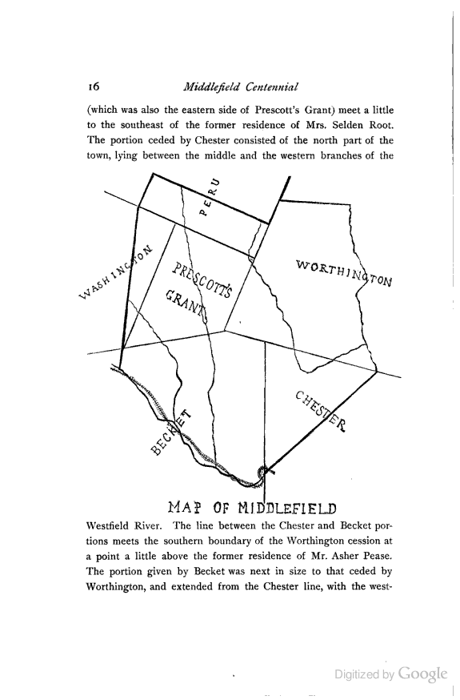

Figure 1. Map of Middlefield
This map shows the town of Middlefield, with Prescott’s Grant at its center and with the land that was taken from the surrounding towns to form the town of Middlefield.

Middlefield’s isolated nature, even after incorporation, as well as the geography itself, was prohibitive to the growing of crops for sale. The hills and rocky terrain proved difficult for farmers to do much more than simply feed his family, and so instead the residents turned to livestock, particularly sheep in the early years. The area boasted an abundance of streams, and by 1794 the first fulling mill had been built by Moses Herrick on what would later be known as Factory Brook. This fulling mill and the others which were built to process wool encouraged the raising of sheep by farmers. The sheep thrived on the rocky hills and their wool was easily transported to the mills along Factory Brook where it was carded, spun and woven into cloth. Sheep were so numerous in Middlefield that in 1845 there were 9,840. By 1870 the woolen industry reached the height of its prosperity. Eventually the town’s isolated location proved to be a disadvantage. The large mills in the Eastern part of the state had begun relying on immigrant workers who could be paid lower wages and worked for longer hours. Steam power, which was more efficient and generated more power than the water wheel, also came into use in the industrial centers. In Middlefield the last woolen mill closed in 1890, almost one hundred years after Herrick’s fulling mill had first been erected on Factory Brook.
However, sheep were not the only livestock which flourished in Middlefield’s hills. When the Boston and Albany Railroad was constructed in 1841, it passed along the border between Chester and Middlefield and allowed for easier transport of cattle to market. This prompted farmers to improve their cattle herds through higher quality imported stock. By 1840 a shorthorn Durham bull had already been purchased by a Middlefield farmer from the purebred Rensselaer stock of New York. Eldridge Pease also bought “Roan Duke” from a New York herd; this bull was one of only three bulls sired by “Grand Duke” who had been imported from England for $1,000 guineas. Along with other superior cattle, these new bulls improved the quality of Middlefield herds. According to the Historical Discourse given at the One Hundredth Anniversary of the town, “The Durhams ...were so improved that the town became famous for its ... cattle.” It was this new influx of cattle and improved herds which is credited with inspiring the farmers of Middlefield to hold a Cattle Show of their own.

The Middlefield Cattle Show
In the summer of 1855 a group of Middlefield farmers held a small agricultural exhibition. The Berkshire Cattle Show had been in operation for forty-five years and was only several towns over from Middlefield, so it is quite likely that Middlefield farmers had attended the show, as well as others in the state. This was the “Golden Age” of Agricultural Fairs; the state was once again funding agricultural societies and supporting the cost of their premiums. Middlefield’s farmers decided to build on the small exhibition of the year before and begin holding their own annual Cattle Show. In August 1856 they gathered to form an organization to run the fair for which temporary officers were elected. An exhibition of stock was held on September 16th which was attended by “a large concourse of people.” After the success of the first full Cattle Show, a permanent organization was formed under the name Highland Agricultural Society. This society would continue to hold the Middlefield Fair until the present day. The Cattle Show of 1857 occurred on a cold and windy day, but still boasted 400 head of cattle as well as sheep, horses and swine. The nearby towns had already begun a tradition of competing for the largest string of oxen and steers. In 1857 the winner was Chester with sixty-five yokes decorated with bells and ribbons and pulling a wagon upon which a band played the national anthem.
The Highland Agricultural Society continued to grow each year. In 1858 Matthew Smith, a prominent member of the town and president of the society, donated a portion of his pastureland near the town center for use as a fairgrounds. This site provided a wide view of the surrounding hills and pastures and became one of the notable aspects of the fair. In that year the fairground was fenced and the society began charging ten cents for admission. The following is a description of the fair in that year by an eighteen year old boy:
Our Cattleshow took place on Tuesday and Wednesday, Sept. 28 and 29, and is acknowledged by all to have been a complete success. A fine looking fence was built around the ground. It was six feet high and therefore inaccessible to all save a few of the most determined spirit, viz., Orrin Pease was lead out by the collar, and others were chased over the fence. Matthew stood at the entrance and took admission fees of ten cents....
Upon the first day 407 head of cattle were exhibited to a somewhat small collection of people, though 39 dollars were taken, and but 37 on the second day. The Peases did not bring their cattle and if they had there probably would have been over 500 head on exhibition. 68 horses were entered...

In 1859 the Highland Agricultural Society sought incorporation by the state but faced opposition from residents of the nearby town of Huntington which had also held a cattle show the previous year. An entire delegation from Huntington appeared before the General Court at Boston to argue in favor of their town being granted the charter. Matthew Smith was the lone representative from Middlefield but he addressed the General Court in such a forceful manner that Middlefield was awarded the charter. When Matthew Smith returned home with the good news, the townspeople responded with excitement. Several of the more jubilant celebrators brought the old town cannon to the fairgrounds where they fired it long into the night, making sure that it was aimed down into the valley towards Huntington.
It was also in 1859 that the exhibit hall at the fairgrounds was built at the insistence of the ladies. Beginning with the Berkshire Cattle Show, Watson had stressed the importance of exhibitions of women’s handiwork, particularly domestic woolen manufacture. Now, after nearly fifty years, the women had come to expect such an event to showcase their work and demanded that the men build them an exhibit hall. The building was completed in time for that year’s fair at a cost of $925. The hall was two stories tall; the first floor was used to display the exhibits and the second floor was used as a dinning hall until an annex was added to the building. The hall also had a flat roof with a railing. For five cents visitors could climb to the top to view the surrounding countryside of Becket, Chester, Peru, Worthington and Washington.

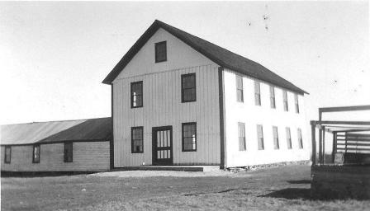

Figure 2. Middlefield Fair exhibit hall. Date unknown, taken after the flat roof was covered with a peak to prevent snow damage, and before electricity came to the fair in the early 1930s.
The Highland Agricultural Society received generous contributions from the state in support of its premiums: $460 in 1860 and an increase to $600 a year in 1862. Delegates from the State Board of Agriculture visited the fair to observe and report on the society and its cattle show. They observed that Middlefield held good grazing land and that the show provided farmers the opportunity to compete among one another without interference from wealthy owners of expensive stock. The following are observations made by the delegates:
It is a mistake to suppose that the improved and large herds of cattle cannot thrive in the mountain pastures. The Middlefield farmers raise their broad-hipped Durhams mainly by the agency of grass, with little aid from grain.

The show of oxen and steers was the best I have ever seen at a county show, not for the number and perfection of training, but for the size and early maturity; almost every yoke especially of steers, was remarkable.

Among the three hundred head on the fairgrounds, by far the largest number was composed of Shorthorns. Better specimens of the blood are seldom seen.

It was evident that Middlefield farmers and those of adjacent towns had gained a reputation for raising good stock, as was fully shown by the number of good judges and lovers of good stock present, and willing to pay large prices for it.

The Middlefield Cattle Show was illustrative of the agricultural focus of the town which formed its main identity. In 1863 when the state decided to establish an agricultural college, several members of the Highland Agricultural Society believed that Middlefield would be a better site for the college than Amherst. In 1864 they raised fifty dollars to oppose Amherst but never acted on the matter. Middlefield may not have become the site of the state agricultural college, but it remained a center of agriculture in the area. In the Society’s 1865 report Jonathan McElwain wrote:
Our annual fair has become an institution, fixed, settled and indispensable; it did not spring into existence in a moment; it took time, thought and money. Our Agricultural Society and Fair we love; we look to it for mutual instruction and help. We look to it for a delightful and healthful interchange of social joys.

Education at the Fair
According to Neely, “the first and most common claim of the agricultural fair is that it is an educational institution.” This is what Elkanah Watson had in mind when he first tied his pair of Merino sheep beneath a tree on the Pittsfield town common. He wished to educate the rural farming community on the merits of new breeds and agricultural innovations. It is for this reason that Watson organized the first Berkshire Cattle Show in 1810; he saw the agricultural fair as a vehicle for agricultural education.
The average farmer might not have been drawn to the event due to the educational benefits of attending an agricultural fair, but the premiums succeeded in luring them in to enter their livestock and crops. In order to continue to win these premiums - Middlefield alone offered $600 in premiums in 1862- the farmers had to improve their livestock to keep up with the competition. In Middlefield the cattle show provided a chance to display the high quality of cattle raised by local farmers and competition was fierce. For such a rural community in the isolated hilltowns, the people of Middlefield greatly impressed visitors to the cattle show. According to Charles K. Tracy who visited the fair in 1859 on behalf of the Massachusetts Board of Agriculture, “the exhibition of cattle cannot be excelled, as to quantity or quality, in the state.” These sentiments were repeated throughout the following reports to the Board of Agriculture; the observers were uniformly impressed by the ability of Middlefield farmers to raise such quality stock on grass alone. In 1862 Paoli Lathrop visited the Middlefield Cattle Show, and commented on the breeding of the cattle:
Among the cattle were many fine representatives of the Short-horn blood, a few of which were thoroughbred, but most of them were bred by crossing with our common stock. This favorite breed has become widely distributed throughout the limits of the society, and produces the most marked improvement, making the farmers, (the skeptical,) to realize that “blood will tell.”

In this observation we can see that the farmers had been diligently improving the quality of their stock, including by purchasing “thoroughbreds,” or purebred stock, rather than simply breeding what was available locally. Lathrop seems to think that this was a reflection of farmers’ education in breeding practices and hereditary traits in livestock. This education would most likely have come from the fair which had been operating annually for seven years by that time.
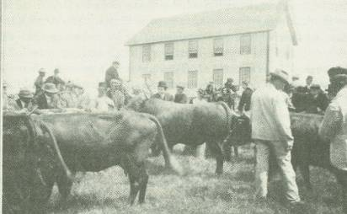

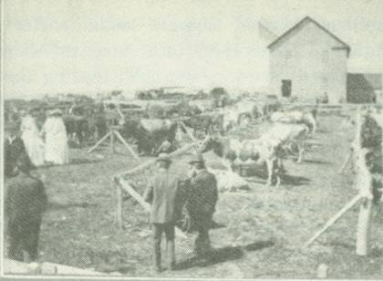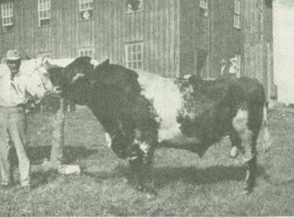

Figure 3. Cattle on display at the Fair, the bull in the bottom picture won a first prize.
The cattle show provided a venue for much more than just cattle, in 1859 the exhibit hall was newly built and provided women a chance to participate in competitions for the first time. Tracy noted during his visit that the hall was already “too small for their use ... it was well filled” Since this was the first year in which women could enter their handiwork for competition this large number of entries may not have been the norm, but in any case it reveals the enthusiasm with which women participated in the fair. Much like in the cattle show, the competitive spirit of the women inspired them to increase their skills in domestic manufacture and handiwork in order to display their work. Women who won first prize were often approached to teach the daughters of other families so that the girls could learn new techniques and better their skills.
It is not by chance that the Golden Age of Agricultural Fairs coincided with the development of new agricultural machinery. “It all began with the reaper,” Marvin McKinley wrote in The Wheels of Farm Progress, by which he was referring to the mechanical reaper developed by Cyrus H. McCormick in 1831. This reaper was a horse drawn machine that cut grain and laid it out so that it could be easily raked and bound with twine. The previous method had involved cutting grain by hand with a scythe and then racking it into bundles, an exhausting and tedious process. The agricultural fair provided a venue for new inventions such as these to be demonstrated in competitions against the traditional methods. Investing in a new machine such as the mechanical reaper posed a big risk for farmers who were often struggling to simply make ends meet; they first had to be convinced of the effectiveness and efficiency of the new machines. Avery notes that, “although they really wanted devices to remove the drudgery from their lives, they also wanted to be shown that an invention would work.”
The period from 1830 to 1880 was one of major breakthroughs in mechanical applications to agriculture. In fact, McCormick had competition for his reaper; Obid Hussey claimed that he had invented the reaper first and actually received a patent before McCormick. This rivalry was followed by Pells Manny who began manufacturing a reaper similar to McCormick’s in 1855 and was sued for patent infringement.
The drama over the invention of the mechanical reaper was followed by other mechanical developments. In 1837 John Deere used an old saw blade to make the first steel plow which revolutionized the use of the plow. Corn planters and cultivators extended the ability of farmers to raise corn after 1850. Jerome Case achieved world fame when his threshing machine was awarded a gold medal at the Paris Exhibition in 1878. Although workable designs for threshers had been around for nearly ninety years, it was Case’s success at demonstrating his machine at a fair which made it popular. The next step in agricultural modernization was the combine harvester, combine for short. The Moore and Hascall machine, built in 1834 and patented in 1836, was the first workable combine but it failed to reach common use. It was only later, when the price of wheat fell, that the steam powered combine harvester came into widespread use as a way to reduce the cost of supporting the required horses. Once again it was at the agricultural fair that farmers learned about the benefits and savings that a combine harvester would provide.
Although Middlefield farmers did not raise crops on the same large scale as farms in the West, they still benefited from some of these new machines. John Deere plows made plowing the rocky soil for food crops easier and hay balers which came out of the mechanization period allowed for more efficient harvesting of hay to feed the cattle and sheep herds. By the early 1920s at least one farmer in town owned a hay baler, and eventually more farmers acquired the machines. For Middlefield farmers, the fair provided the chance to see these machines up close and in demonstrations. This likely helped to convince them to invest in the machines or rent them during the harvest.
Another common aspect of the agricultural fair that Middlefield exhibited was the agricultural discussions and talks. At the second Berkshire Cattle Show, Watson gave an address extolling the virtues of American agriculture and domestic manufacture. This became an annual occurrence at the fair. Many other fairs included these talks and discussions as well; they provided a venue for the distribution of new ideas and scientific advances in the field of agriculture. The typical farmer could not attend an agricultural college and might not even be literate, and therefore able to read about new ideas, but at the fair this was all presented to him.
Middlefield too included this tradition at its early cattle shows. In the evening of the first day of the fair, “they held social gatherings either in the town hall or the exhibition hall, and there were discussed problems relating to the farm.” The Highland Agricultural Society began holding “institutions,” or workshops, at which they provided information and educated local farmers on a variety of subjects. In 1894 the society held four workshops for farmers in the area: in Becket on “Cattle hygiene, care, housing, feeding”; in Chester on “Work of the Dairy Bureau” and “Composition of milk”; in Middlefield on general subjects and “Use of the score card.” It was with events such as these that the farmers of Middlefield set upon the task that Watson began in 1810, that of educating the average American farmer to become more efficient and profitable.

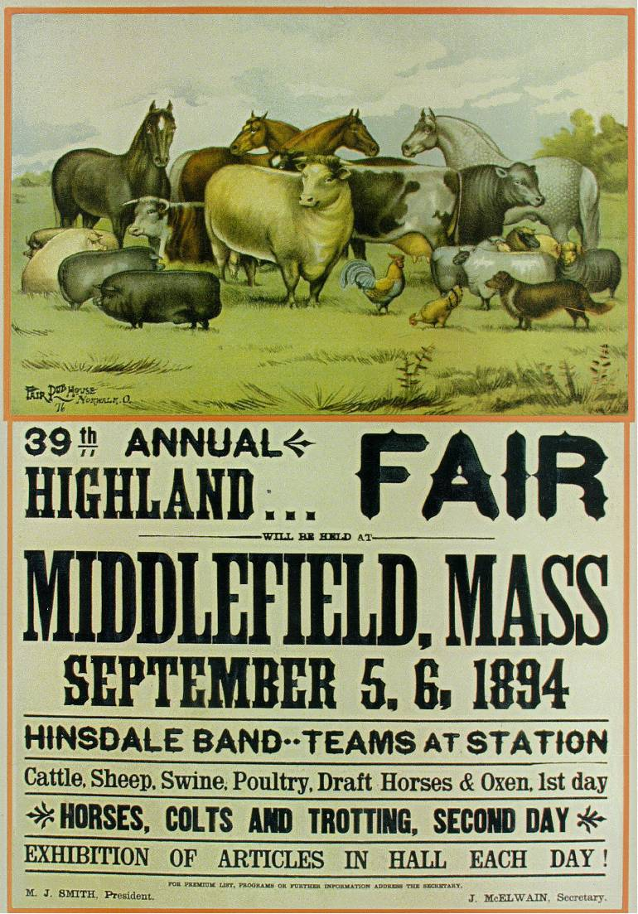

Figure 4. Poster for the 1894 Middlefield Fair which was mentioned above, reproduced for sale at the fair.
Entertainment at the Fair
Elkanah Watson may have envisioned the agricultural fair as having a mainly educational purpose, but he also realized that in order to draw people to the event they would need entertainment as well. Watson started with competitive events, parades of livestock and talks on agricultural topics to entertain the crowds and educate them in the process, but soon entertainment developed a foothold in the agricultural fairs tradition which purists would condemn. As early as 1850, during the “Golden Age,” fairs were already being accused of losing their educational purity.
The growth of entertainment at the fair was prompted by a need for agricultural societies to raise their own funds in order to supplement the income from state grants. The trend towards greater entertainment also seems to be the result of a desire on the part of farmers and their families for an enjoyable holiday.
Neely writes that horse racing was “by far the most characteristic sport of the traditional agricultural fair.” Horse racing was very popular in rural communities and drew large crowds, but also presented a problem for fairs. The races drew large crowds and resulted in large gate receipts, but quality racetracks were expensive to build and maintain. This created a vicious cycle in which many agricultural societies became trapped; they needed to hold races to raise money to support the fair, and yet the races themselves became quite expensive. Still the societies could claim that horse racing held a legitimate role at the fair in addition to drawing crowds. Most races featured trotters and pacers; these driving horses provided the most common transportation at that time. Racing was seen as a chance to exhibit the best driving horses and therefore improve the breed. According to Neely, horse racing emerged as a hybrid form between pure education and entertainment.
At the Middlefield Fair, horse racing was a popular sport as well. In 1865 Hollis Tidd, a delegate from the Massachusetts State Board of Agriculture, visited the annual fair and observed the display of horses which was held on the second day. He noted that the attendance swelled on the second day due to the horses and that:
the whole number of horses, of all ages, present, was sixty, consisting of stallions, carriage horses, breeding mares with their colts, and business horses; among these were a few well matched, good driving carriage horses.

The horses were displayed on the fairground’s driving course to exhibit their training and actions, but as Tidd observed the “track was not in condition to test their speed.” The difficulty of driving the horses on the rough track resulted in tension within the Society. According to Edward Church Smith, “At one time in the early days [of the fair] the horse lovers endeavored to have the fair removed to a place where a more suitable track could be secured, and went so far as to appeal the legislature.” This movement was defeated but the society did invest in hiring an engineer who improved the quality of the track and races were held for many years. By the early twentieth century, the fair still had trotters and pacers competing on its track, as well as new events. According to the memories of Helen Alderman, peg races were very popular among the young people. Fully harnessed and hitched horses were lined up along the track and on the shout of “Go” the drive would hurriedly unharness the horse and hang the harness upon a peg. At the next signal the driver would retrieve the harness and re-harness the horse to the wagon. The quickest person to complete this task was awarded a prize.
The agricultural ball was inaugurated by Elkanah Watson at the fourth Berkshire Cattle Show in 1815 and demonstrates his acknowledgement that not all events had to have an educational purpose. Many other shows picked up this practice and it was very common for an agricultural ball to close the event. The Middlefield Fair shared this tradition for several years although according to Smith, it “seldom attended by the best class of people.” Dancing was considered sinful by many at the time and so the ball was replaced by a party to entertain the young people of the community. In 1871 the society voted to abolish the ball as well as prohibit the sale of intoxicating liquors on the fair grounds.
Music was another important aspect of the fair; bands were employed to play in the evenings between speeches and the presentation of awards and premiums. The musical tradition also dates back to the early Berkshire Cattle Shows; it was at the second show in 1811 that Watson arranged for a band to play while the parade marched. Many of the reports from delegates of the Massachusetts Board of Agriculture who visited the Middlefield Fair reported vocal and instrumental music. A later example of the musical tradition is the song “When Cattle Show Comes ‘Round.” This two-step and male quartet was written by Philip Mack Smith in 1912 to be played at the fair. The song captures the spirit of the Middlefield Fair as the people of Middlefield experienced it (see appendix).
The midway was, perhaps, the culmination of the separation between the educational purpose and the entertainment side of the agricultural fair. It served no intrinsic educational function; its sole aim was to entertain and make money. It arose from the tradition of the European market fairs at which food vendors, side shows and entertainment troupes thrived. As the agricultural fairs in America grew they needed larger attendance to support their costs. They also needed to maintain popular interest as farmers started to disappear as large-scale agriculture moved out West.
The percentage of the rural population in Massachusetts in 1850, the beginning of the Golden Age of Agricultural Fairs, was 49.3 percent. This dropped to 33.3 percent by 1870, at the end of the Golden Age. Even as fairs were spreading throughout Massachusetts the populations which they served were decreasing. These numbers continued to fall throughout the twentieth century and made it necessary for agricultural fairs to diversify in order to survive. In Middlefield there was a similar trend; in 1855 when the fair was established the population was 677, the lowest it had been since 1790, but the numbers rose and held steady at a little over 700 for the next twenty years as the fair grew and became established. By 1875 a new decline began, and it would not end until 1930 when the town dipped to a population of only 197. With less than one third of its former population Middlefield and the community would have to find creative ways to keep the fair alive.
The fair’s entertainment and socialization function played an important role for the community. Middlefield residents, as well as the surrounding towns, lived in rural isolation and worked hard to survive. Middlefield winters were harsh and raising crops and livestock was not easy. However, the fair offered a rest from the burden of everyday life and a chance to display that year’s hard work. For such a small, close knit community the fair was likely seen as a family reunion where the whole town came together to celebrate. The community could take pride in the quality of their livestock, which on many occasions was “surprising to a valley man to see all the usual triumphs of the husbandman displayed on the mountains.” The society had not been named “Highland” for nothing – it was a show of pride for these farmers whose livestock, raise in more difficult conditions, could surpass that of the valley. In 1864 a delegate made the following observation:
If no other good were derived from the operations of this society than relaxation from the ordinary pursuits of life, the social re-union of friends,––the mere addition of these to the calendar of the farmer’s holidays; these alone would compensate for all the trouble and expense attendant upon its annual exhibition.

Entertainment and the social aspect of the fair became just as valued by many fairgoers as the educational benefits for which the fairs had originally been founded. But the tension between entertainment and education would also remain, as some wanted to maintain the purity of education at the fair and others saw the purpose of the fair changing to fit new social needs and expectations.

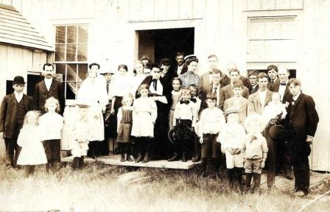

Figure 5. Group picture taken in front of the exhibit hall, date unknown.

Women at the Fair
Women played an important role in agricultural fairs; as one fair enthusiast wrote in The Homestead in 1858, “a fair, without the fair, is no fair at all.” The fair allowed women a degree of equality with men in that they were both spectators and competitors. The competitions provided women the chance to display the domestic goods which they produced, and which they rarely received praise. Their entries included “rugs and carpets, blankets, pillows, quilts, needlework, stockings, skirts, hats, flannels, linen, and other domestic articles.” Women also entered dairy products such as cheese and butter, as well as baked goods, the most important of which was bread. The fair provided one of the rare instances in which the role of women was taken out of the home and showcased by the community as a whole.
Watson had recognized this important role when he first began the Berkshire Cattle Show; he wanted to encourage not only superior quality in livestock but also in domestic manufacture. The livestock show and exhibit of domestic goods went hand in hand: quality wool was needed as well as skill on the part of the women to turn that wool into cloth. On January 12, 1813 Watson held the first “Cloth Show” under the oversight of the Berkshire Agricultural Society. The women were invited to display the “fruits of their industry,” and while many high-quality items were presented for display no women were present to claim their premium prizes. Watson wrote that when “no female was seen to claim the premiums ... I was extremely agitated lest the experiment should fail.” In order to persuade women to leave their homes to participate in the awarding of the premiums, Watson had his wife come to the Cloth Show where the handiwork was displayed. He then sent messengers to the women to inform them that his wife waited to welcome them to the hall. It appears that the women of the time were hesitant about the decency of participating in such an event until a woman’s presence was provided.
The agricultural ball was also initiated by Watson in order to include women in the early Cattle Show. The first ball was held the same year as the cloth show and Watson saw it as more than simply a venue for entertainment, it provided an opportunity by which “to promote domestic manufactures, by exciting emulation, and by inducing females to feel pride in appearing decorated in the works of their own hands, on a public occasion.” Watson strongly believed that domestic manufacture would allow the United States to remain independent from Britain and he strove to promote this ideal. It was ultimately the women who produced the finished product and so Watson worked to include women in the process of improvement through competition at the fair. He “considered [it] of the first importance to the success of the society, to enlist the sympathies and arouse the interest of the females of the country in its operations.”
Watson was not the only one concerned about women’s participation at the fair; many agricultural societies were concerned with their attendance and participation as well. Fair organizers made sure that the fairgrounds would be comfortable and welcoming to women. In 1829 the Hartford County Agricultural Society of Connecticut voted to create a “committee to provide seats for the ladies” and other societies made sure that the grounds were kept free of animal manure and proper sanitary facilities were provided. In the 1850s the Connecticut State Fair decided “a separate saloon should be provided for the ladies, tastefully fitted up with everything necessary for their comfort.” The organizers of the 1836 Cattle Show in Barre, Massachusetts made the mistake of scheduling their fair for a Monday, not realizing that Monday was the washing day for women. Few women attended and only four domestic articles were displayed for exhibition. This reminded men that they must schedule the Cattle Shows around women’s domestic schedules, in order to draw a large female crowd.
Despite the emphasis on women’s importance at the fair, the dominant role of men remained intact. Men organized the fair and determined whether special accommodations such as a separate saloon were appropriate. Men also judged the domestic displays and awarded the premiums. The most popular events of the fair remained in the man’s sphere: speeches, racing and plowing contests. The reports from delegates who visited the Middlefield Fair on behalf of the Massachusetts Board of Agriculture focus most heavily on the livestock, horse racing and speeches which they observed at the fair, providing only a few lines about the ladies’ handiwork department and sometimes saying as little as “The ladies’ department was very fine.” Inequality also existed in the awarding of premiums; a prize bull might be awarded a premium of eight dollars while a rose blanket would receive only three dollars.
Women may have been hesitant to participate in Watson’s cloth show in 1813, but by 1859 the women of Middlefield were insistent that they be provided with a hall in which to exhibit their domestic goods. The Middlefield Fair was only four years old at the time but the society successfully erected a modest exhibit hall that still stands today. In the nearly fifty years since Watson had inaugurated the tradition of a cloth show, women in Western Massachusetts had come to expect the opportunity to display their hard work and domestic products. In this first year of a ladies’ display the new hall was reported to be:
well filled with dairy products, fruits, vegetables, domestic manufactures, with a good display of needle work of the ladies, who, in the mountain towns, are not to be beaten on such an occasion as this

Later delegates would comment on the “good display of manufactures,” stating that it demonstrated “that the ladies felt they had a department in which to act and fill, and in this they succeeded.”
Middlefield women also provided dinners at the fair. These meals were served in an addition which had been added to the exhibit hall by 1871. The meals were prepared by several groups throughout the years, sometimes by wives of the society members and also by the women of the congregational church. Women also achieved at least a degree of power and representation within the Highland Agricultural Society; the governing body contained Directors as well as Lady Directors. Although there are no existing records indicating when the designation of Lady Director was initiated, the title was in use by the early Twentieth Century.

Social Class at the Fair
The Agricultural Fair was supposed to embody the American ideal of democracy and equality. Watson envisioned his Berkshire model as far different and superior to the European tradition of agricultural societies due to the inclusion of the average farmer, yet this was not the reality in most agricultural societies throughout New England. The average farmer may have been included, and the membership fees may have been low enough to allow for that inclusion, but the societies were still controlled by the wealthier members of the community.
Watson himself was a gentleman farmer; he was a businessman who had traveled throughout Europe before settling down in Pittsfield, Massachusetts to begin his hobby of farming. The Massachusetts Society for the Promotion of Agriculture sponsored the Brighton Cattle Show which was held over the course of several days and located upon the site of Boston’s traditional slaughtering yards. The society was run by the elite of Boston and included opulent dinners from which the ordinary working farmer was excluded. The richness of these dinners is revealed in the fact that the U.S. consul to the Azores, John B. Dabney, donated one hundred bottles of his best wine to the banquet in 1820. These lavish affairs were far beyond the reach of the working Massachusetts farmer and did not align with what Watson had envisioned as the purpose of the agricultural fair.
Even away from large urban centers such as Boston, influential men dominated the organizational bodies of fairs. The Hampshire County Agricultural Society which sponsored the Amherst Cattle Show is one such example. The society was run by Alfred Baker, a prosperous farmer, Edward Dickinson, a lawyer and Whig politician, J. W. Boyden, a Harvard trained lawyer, and Luke Sweetser, Amherst’s leading merchant. It was men such as these who presided over many of the agricultural societies throughout New England. Men who had wealth and political influence directed the growth of the societies through their donations of money, land and other resources. They could also help a new society secure a charter for a state sponsored cattle show. The ordinary farmer did not have the same level of influence that these community leaders held.
According to the genealogy records compiled by Edward Church Smith, the Highland Agricultural Society of Middlefield followed this same pattern. Its first president, appointed in 1856, was Ambrose Loveland. Although he is described only as a farmer and “proficient as a singing master,” Loveland was the grandson of Malachi Loveland who had served in the American Revolution, signed the town’s petition for Incorporation and served as a selectman from 1785-86 and 1790-91. Ambrose may have been a simple farmer, but through his grandfather he acquired a degree of influence and respect. The first secretary was Solomon F. Root, a successful businessman and partner in the Blush woolen mill located in Middlefield which produced satinet. Root also came from an influential family; his father was a selectman, town treasurer, representative to the general court, and successful businessman.
In 1857 when a permanent organization was formed for the society, Matthew Smith was appointed president. Smith was selectman in 1850 and 1856-57, he taught school for several years and represented the town in the General Court in 1878. He, too, came from a family with heavy involvement in the town; his father held the positions of Captain of the local militia, Justice of the Peace, assessor, school committee, Town Clerk, and representative to the General Committee. Edwin McElwain was appointed secretary in 1857, and he was also a businessman. He ran an agricultural store in Springfield, Massachusetts and participated in other business ventures. His father also served as selectman and representative to the General Court. The treasurer at this time was the aforementioned Solomon F. Root.
All of these early leaders of the Highland Agricultural Society were influential men in the community from established families, and many were successful businessmen. Their positions in the community allowed them to begin a successful agricultural fair which would win the praise of many who visited it.
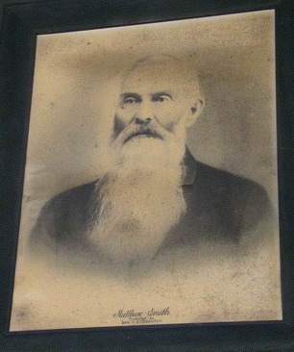
Figure 6. Picture of Matthew Smith, the first official president of the Highland Agricultural Society and donator of the land on which the fairground is located.

Matthew Smith is regarded as the “father” of the Middlefield Fair: he donated the land upon which the fairground is located and it is he who, as the sole representative for Middlefield, argued in so “forceful a manner” that Middlefield was awarded the charter for the cattle show. Matthew Smith would not have been able to donate land, especially land so close to the center of town, if he had been an average, struggling farmer. It is also very possible that through his father, who was involved in politics and served in the War of 1812, the General Court was more likely to acquiesce to his request for a charter to hold a cattle show.
Although there were many farmers without family influence or wealth who attended and participated at the Middlefield Fair, the organizational body behind the event was composed of men beyond the means of the typical farmer. It was the efforts of men of a certain class who started the fair and gave it the firm foundation which has allowed it to continue for over a century and a half. Watson may have intended for the fair to be an organization of equality, but men of wealth and influence rose to the top and guided the society.

The Fair in 2010
The institution of the agricultural fair reached its bicentennial this past summer. In 1810 Elkanah Watson held his Berkshire Cattle Show and inaugurated the Berkshire model of agricultural fairs which spread across the country. Two hundred years later on August 13-15, 2010 the Highland Agricultural Society held the 155th Middlefield Fair. The fair is still held on the same grounds that Matthew Smith donated in 1858 and the exhibit hall still stands tall at the highest point of the hill. Over 2,000 people attended over the three days and, despite a long history of rain at the fair, enjoyed beautiful weather. The first floor of the exhibit hall was overflowing with entries of vegetables, flowers, baked goods and handicrafts, much as Tracy had reported in 1859. Much has stayed the same at the fair over the past 150 years, but much has changed as well.
The main entertainment is no longer the horse races; motorized vehicles have replaced horses in both work and entertainment. The truck pull, the most popular event, has been traditionally held on Friday night, but this year it was moved to Saturday. The truck pull is an adaptation of the horse and oxen pulls that have been held at agricultural fairs since their inception. Once trucks had replaced horses and oxen as the primary form of transportation it was only natural that trucks be used in the same competitions of strength. The first truck pull was held at the fair in 1981. It has become a favorite attraction and draws the largest crowd. The pull traditionally started around 5 p.m., soon after the gate opened at 4, and would typically run until past midnight. Some years the pulls have run as late as 4 a.m. In 2010 the fair board decided to change the start time to Saturday at 1 p.m. in order to prevent it from going so late. Even with the earlier start time, the pull still lasted thirteen hours and ran until 2 a.m.
Friday night the “burnout” contest was held and attracted a sizeable crowd. In a burnout contestants park their car, truck, motorcycle or quad on a metal sheet and then spin their tires, producing smoke and possibly blowing the tires. To determine the winner, “judges will consider appearance of the vehicle, sound, amount of smoke, stalling, missed shifts, etc., while also listening to the applause of the crowd.” The burnout contest is relatively new to the fair and was first held in 2007 but has become a crowd favorite.
These new motorized events would likely have drawn the same criticism from fair purists as the horse races did during the nineteenth century. There is little educational benefit evident in truck pulls or burnout contests. They exist purely for entertainment value, and yet also reflect the societal changes since the fair’s inception in 1855. People in Middlefield no longer rely on horses or oxen to perform labor, trucks and other equipment are now used. Some could even argue that the truck pull provides an educational opportunity for people in town as the younger generations are taught how to repair, rebuild and service the trucks used at the pulls. This argument is similar to the one used to justify horse racing, and is open for debate.
One tradition that has remained relatively intact is the horse and oxen pulls. The horse pulls are traditionally held on the Saturday of the fair and the oxen pulls on Sunday. Despite the fact that these animals are no longer used for daily farm operations, people continue to breed and raise them in order to compete in these pulls. Competitors usually follow the fair circuit throughout the summer, competing at a different venue each weekend. These contests do not draw large crowds but it has a dedicated following.
New to the fair in the last two years is the “Massachusetts State Chili Cook Off Championship”, hosted by CASI. The cook off was initiated by one of the food vendors who has brought his trailers to the fair for over fifty years. He heard about the cook offs organized by CASI and thought that it could be a fun new addition to the fair. The contest has been a success with contestants coming from as far away as Texas and Maryland. In the two years that the cook off has been held, it has become very popular and is on its way to becoming an established institution at the fair. This event presents some educational opportunities; it teaches participants and observers how to make the best chili and it also provides entertainment for the fair.
Over the 150 years since its founding the Middlefield Fair has survived and retained many of the elements of Elkanah Watson’s model for the agricultural fair. Watson envisioned the agricultural fair as an institution through which to educate the community and promote domestic manufacture. The Middlefield Fair may draw people through entertainment such as the truck pull, but beneath this is the original agricultural purpose.
Middlefield is no longer a farming community and many residents no longer have a connection to or knowledge of where their food comes from. At the fair many children have their first encounter with the cows that produce their milk and beef, as well as with the sheep that produce wool for their clothing. The fair presents the opportunity for both young and old to interact with the farm animals that were a daily part of life only a few generations ago. 4-H and other youth groups create and enter educational displays on everything from “Going Green” to “Bee Keeping.” The town historical society runs the Farm Museum which contains old farm tools as well as pictures of Middlefield from the nineteenth and twentieth centuries. This provides fairgoers the opportunity to see how life has changed in the town from its founding to the present. As the movement for local production of food and home gardens spreads, the fair allows participants to showcase the produce from their gardens. The comments from the judges about these entries help to educate contributors on how a prime zucchini, carrot or tomato should look when picked.
One could wonder what Matthew Smith and the other founders of the fair would think of it today. Elkanah Watson may have objected to the loss of strict educational focus, but the people of Middlefield seem to have valued the social aspects of the fair even more. It provides a chance for the entire community to come together to compete, relax, and reconnect. As Jonathan McElwain wrote in 1865, “We look to it for a delightful and healthful interchange of social joys.” For a small town of 500, the fair fosters a strong sense of community and pride.
The Middlefield Fair has had its trials, from the decline of agriculture and population in the region to its near collapse in 2006 when the Society’s funds were stolen, but despite this the fair has persevered. The fair began to really struggle when the state withdrew its funding for the premiums during the 1990s and as a result the cost of the prize money fell entirely upon the fair for the first time in its history. Then in 2006 it was discovered that the society’s bank account was empty. The fair almost came to an end but when the community realized what had happened many residents stepped forward to provide donations and volunteer. The fair has grown in the past five years; new events have been added, $5,000 of electrical work has been done on the grounds, the cattle show has been reestablished, and plans are underway to restart the poultry and rabbit show along with the sheep show. The dedication of the volunteers and the community to the fair is a testament to the role that it plays in the town. The fair is an institution which the residents of Middlefield will not allow to fade away. It is a tradition which they are determined to carry on for another 150 years.

Conclusion
It is hard to judge just how much of an impact the agricultural fair has had on farmer education, but the fact that the practice spread across the country and has lasted to the present day indicates the importance with which it was viewed.
Today there are thirty annual fairs in operation in Massachusetts. There is the Eastern States Exposition, known as the Big E, which runs for seventeen days and draws an attendance of over 1.2 million. Then there are the fairs like the one in Middlefield with an attendance of a little over 2,000 people. The agricultural fair has evolved in order to survive the various changes that have occurred throughout the past two hundred years. It has changed from an institution whose sole focus was farmer education to one of entertainment and education for a largely urban population.
Through the venue of the agricultural fair, one can track the changes from the days of domestic manufacture of woolen cloth, to the decline of agriculture, and to the present trends for locally grown produce. The Middlefield Fair is just one example of the agricultural fair in New England but it offers a unique view of the history of the community and agriculture in the region. It is a proud tradition which the people of Middlefield are determined to carry on as a way to preserve the history of the town as well as to continue to educate the community.

AppendixaA

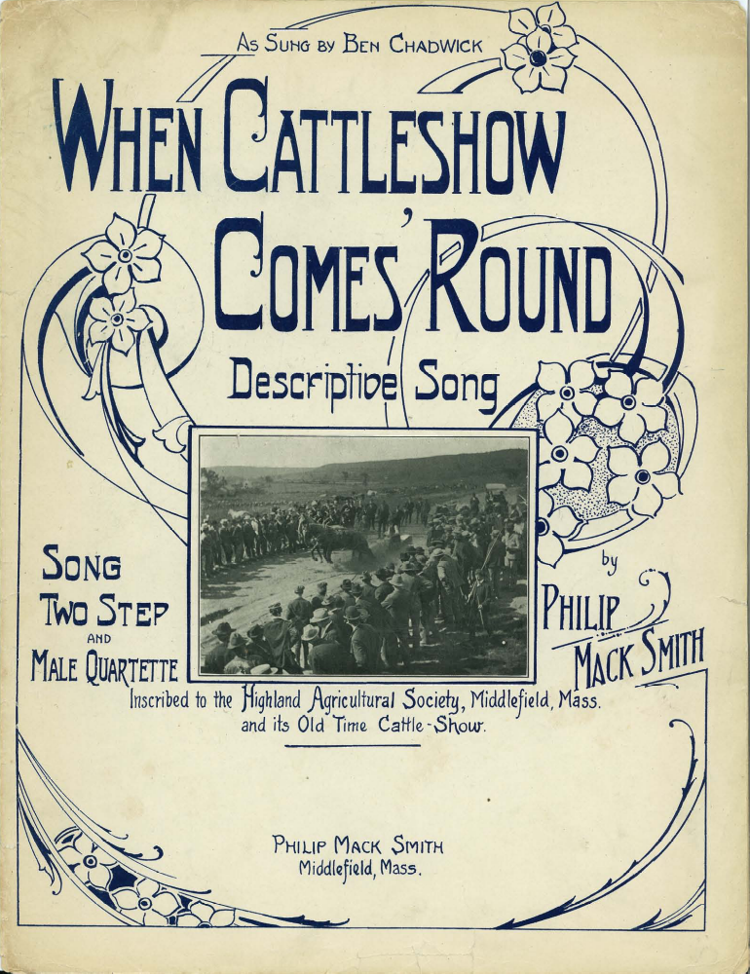

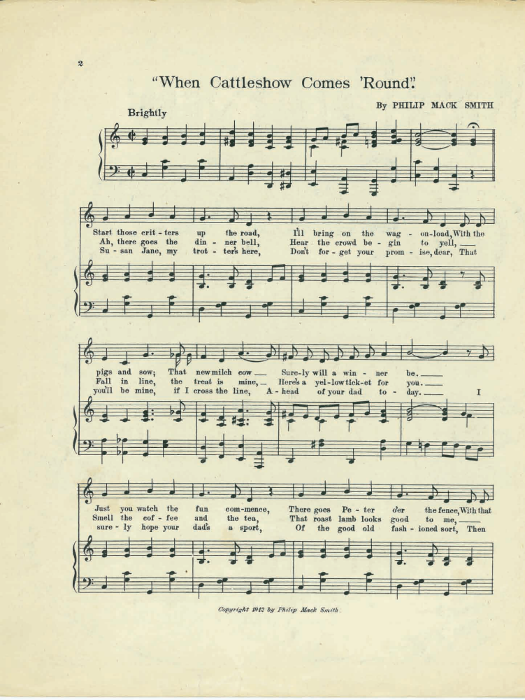

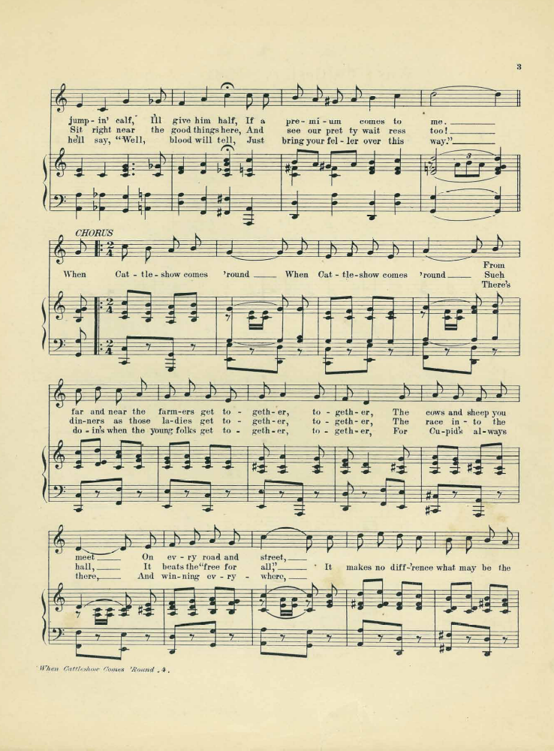

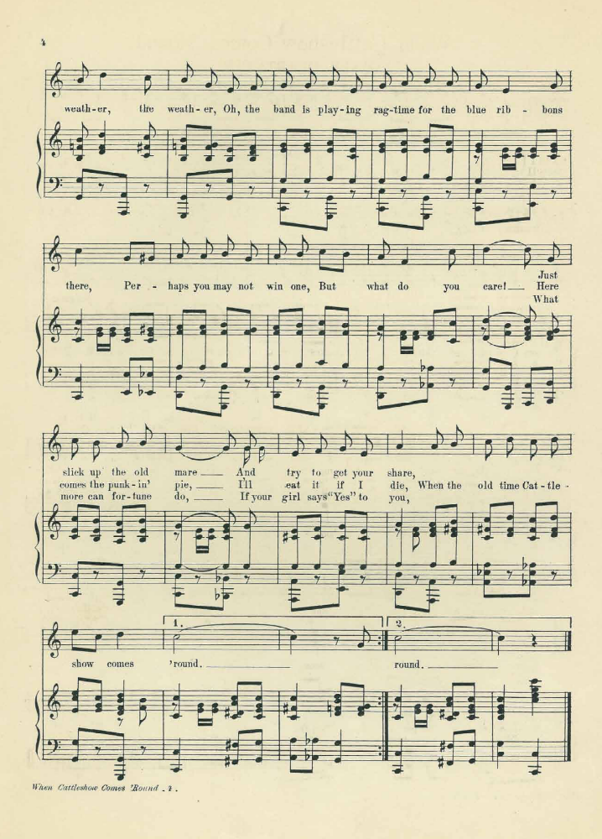

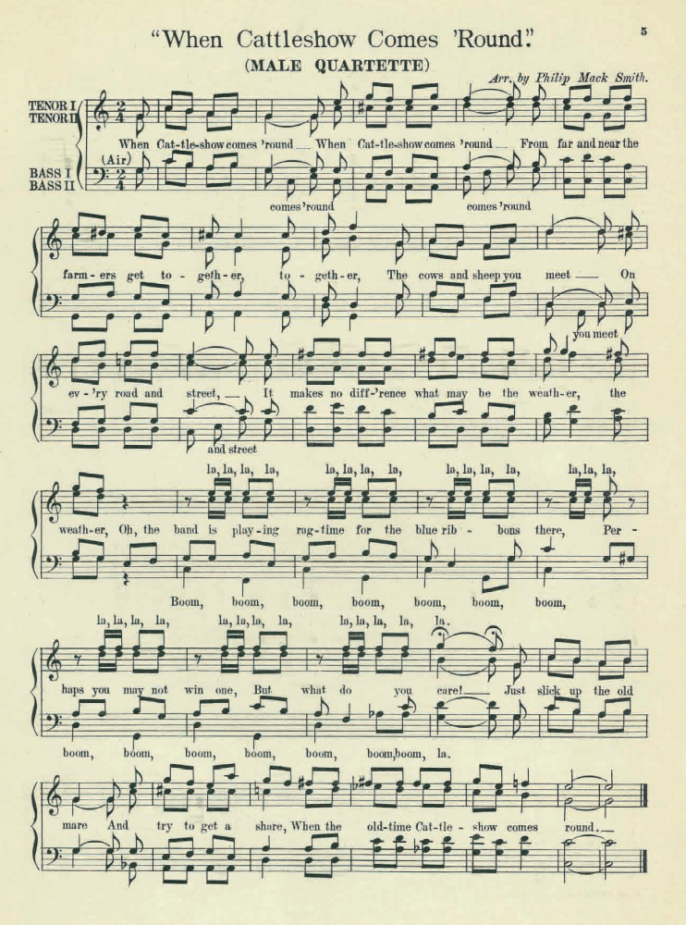

Primary Source Bibliography

“Big E Attendance.” The Big E. http://www.thebige.com/fair/generalinfo/Attendance2010.asp (accessed November 8, 2010).

“Burnout Contest.” The Middlefield Fair. http://middlefieldfair.org/BurnOutContest.aspx (accessed November 7, 2010).

Lathrop, Paoli. “Highland,” The Tenth Annual Report of the Secretary of the Massachusetts Board of Agriculture, Massachusetts: (Boston: Wright & Potter, State Printers, 1863): 391-392.

Perry, Elijah. “Highland,” Twenty-fifth Annual Report of the Secretary of the Massachusetts Board of Agriculture (Boston: Wright & Potter, State Printers, 1878): xxviii-xxix

“Photo Gallery” Middlefield, Massachusetts. http://www.middlefieldma.us/Gallery.php (accessed November 8, 2010).

Smith, Philip Mack. “When Cattle Show Comes ‘Round” Middlefield, MA. 1912. Can be found in the possession of the Middlefield Historical Society.

“Highland Agricultural Society,” Forty-Second Annual Report of the Secretary of the Massachusetts State Board of Agriculture, Massachusetts: (Boston: Wright & Potter, State Printers, 1895): 283-284

Tidd, Hollis. “Highland,” Thirteenth Annual Report of the Secretary of the Massachusetts Board of Agriculture (Boston: Wright & Potter, State Printers, 1866): xxii-xxv

Tracy, Charles K. “Highland Agricultural Society,” Seventh Annual Report of the Secretary of the Massachusetts Board of Agriculture, (Boston: Wright & Potter, State Printers, 1860): 181182

Vincent, Herman. “Highland,” Nineteenth Annual Report of the Secretary of the Massachusetts Board of Agriculture (Boston: Wright & Potter, State Printers, 1871): xx-xxi

Secondary Source Bibliography

Avery, Julie A. Agricultural Fairs in America: Tradition, Education, Celebration. East Lansing, Michigan: Michigan State University, 2000

Borish, Linda J. “‘A Fair, Without the Fair, is No Fair at All’: Women at the
New England Agricultural Fair in the Mid-Nineteenth Century.” Journal of
Sport History 24, no. 2 (1997): 155-176.

Essex Agricultural Society, "Fair History," Topsfield Fair, http://www.topsfieldfair.org/fairhistory.php (accessed October 4, 2010).

Feintuch, Burt and Watters, David H. eds., The Encyclopedia of New England (New Haven & London: Yale University Press), s.v. “Agriculture.”

Galvin, William Francis. "Massachusetts City and Town Incorporation and Settlement Dates," Citizen Information Service, http://www.sec.state.ma.us/cis/isctlist/ctlistalph.htm#M (accessed March 23, 2009).

Kelly, Catherine E. “‘The Consummation of Rural Prosperity and Happiness’: New England Agricultural Fairs and the Construction of Class and Gender, 1810-1860” American Quarterly 49, no. 3 (Sep. 1997), p. 574-602

Marti, Donald B. Historical Directory of American Agricultural Fairs. Westport, Connecticut: Greenwood Press, 1986

Massachusetts Historical Commission. “Middlefield Associated Regional Report: Connecticut Valley” MHC Reconnaissance Survey Town Report. 1982

Neely, Wayne Caldwell. The Agricultural Fair. (New York: Columbia University Press), 1935

Pease, Willard A. “The Highland Agricultural Society”, Sequi-Centennial Address, Published by the town committee, Middlefield: 1933

Smith, Edward Church. A History of the Town of Middlefield, Massachusetts. printed by the town of Middlefield, 1924

Smith Edward P. “A Historical Discourse,” A Memorial of the One Hundredth Anniversary of the Incorporation of the Town of Middlefield, printed by the town of Middlefield, 1883

Sternagle, Mary E. Middlefield History. Ashland, Ohio: Bookmasters, 1985

Edward Church Smith, A History of the Town of Middlefield, Massachusetts. printed by the town of Middlefield, 1924, p. 143
Oxford English Dictionary
Wayne Caldwell Neely, The Agricultural Fair. New York: Columbia University Press, 1935 p. 3-7
Julie A. Avery, Agricultural Fairs in America: Tradition, Education, Celebration. East Lansing, Michigan: Michigan State University, 2000 p. 11
Donald B. Marti, Historical Directory of American Agricultural Fairs. Westport, Connecticut: Greenwood Press, 1986 p. 2
Neely, p. 14-15
Neely, p. 30
Neely, p. 29-30
Avery, p. 11
Neely, p. 38
Neely, p. 36
Avery, p.11
Avery, p.12
It is not known if the term “cattle show” was used because the main focus was on cattle or if it was simply seen as the most important aspect of the exhibition. Regardless of the original reason for the name the term cattle show would become the most common term until a gradual transition to calling the shows agricultural fairs, or simply fairs.
Avery, p.12
Marti, p.6
Neely, p.47-48
Neely, p.64
Neely, p.63
Marti, p.6-7
Essex Agricultural Society, "Fair History," Topsfield Fair, http://www.topsfieldfair.org/fairhistory.php (accessed October 4, 2010).
Neely, p.71
Avery, p.13
Neely, p.74-75
Neely, p.77
Avery, p. 13; Neely, p. 85-86
Neely, p. 84-87
Edward Church Smith, A History of the Town of Middlefield, Massachusetts. printed by the town of Middlefield, 1924, p. 19-20
Smith, Edward Church, p. 30
William Francis Galvin, "Massachusetts City and Town Incorporation and Settlement Dates," Citizen Information Service, http://www.sec.state.ma.us/cis/isctlist/ctlistalph.htm#M (accessed March 23, 2009).
Smith, Edward Church, p. 29-30
Edward P. Smith “A Historical Discourse,” A Memorial of the One Hundredth Anniversary of the Incorporation of the Town of Middlefield, printed by the town of Middlefield, 1883, p 14
Smith, Edward Church, p. 48, wording of the petition for incorporation
Smith, Edward Church, p. 48
Mary E. Sternagle, Middlefield History Ashland, Ohio: Bookmasters, 1985 p. 9, figure 7
Fulling mills were used to improve the quality of rough home woven woolen cloth by using hammers and solutions that shrank the cloth and raised a ‘nap’ of fibers. The cloth was then sheared to give it a soft feel and smooth look.
Massachusetts Historical Commission. “Middlefield Associated Regional Report: Connecticut Valley” MHC Reconnaissance Survey Town Report. 1982 P. 8
Edward Church Smith, p. 218
Edward Church Smith, p. 172
The Rensselaer stock which is referenced is likely from the herds of imported cattle from Rensselaer County, New York. Several men, including Gen. Stephen Van Rensselaer, began importing purebred cattle from England in the early 19th century to improve their herds. Many of the resulting offspring were in high demand throughout the region. The imported cattle included the Durhams. George R. Howell, and Jonathan Tenney, History of the County of Albany, New York: W.W. Munsell & Co. Publishers, p 335-336 accessed through books.google.com
According to the Inflation Calculator at http://www.westegg.com/inflation/infl.cgi $1,000 guineas in 1840 is the equivalent to $35,438.01 in 2009.
Edward P. Smith, “A Historical Discourse,” A Memorial of the One Hundredth Anniversary of the Incorporation of the Town of Middlefield, pamphlet printed by the town of Middlefield, 1883, p 39
Mary E. Sternagle, Middlefield History Ashland, Ohio: Bookmasters, 1985 p. 352 Edward Church Smith, p. 174
Edward Church Smith, p. 174
Edward Church Smith, p. 175
Sternagle, p. 353
Sternagle, p. 357
“Photo Gallery” Middlefield, Massachusetts. http://www.middlefieldma.us/Gallery.php (accessed November 8, 2010).
Edward Church Smith, p. 178
Edward Church Smith, p. 179
Sternagle, p. 366
Neely, p. 155
Edward Church Smith, p. 178
Charles K. Tracy, The Seventh Annual Report of the Secretary of the Massachusetts Board of Agriculture, Massachusetts: 1860 p. 181 The Annual Reports of the Secretary of the Massachusetts Board of Agriculture were published each year starting in 1854 and continuing until the early twentieth century.
Paoli Lathrop, “Highland,” The Tenth Annual Report of the Secretary of the Massachusetts Board of Agriculture, Massachusetts: 1863 p. 391-392
Smith, Edward Church, p. 177
Tracy, p
Marvin McKinley quoted in Avery, p. 51
Avery, p. 51
Avery, p. 52
Neely, p. 75
A threshing machine separated the grain from stalks and husks. The manual process involved beating the stalks with flails until the grain was removed and was a very laborious and time consuming. The mechanical thresher made this process fare more efficient and much quicker.
Avery, p. 52-53
Sternagle, p. 288
Willard A. Pease, “The Highland Agricultural Society”, Sequi-Centennial Address, Published by the town committee, Middlefield: 1933, p. 28
“Highland,” The Forty-Second Annual Report of the Secretary of the Massachusetts State Board of Agriculture, Massachusetts: (Boston: Wright & Potter, State Printers, 1895) p. 284
Copies of the poster are in the possession of the Highland Agricultural Society of Middlefield, MA
Marti, p.12
Neely, p.190
Trotters and pacers refers to the gait in which the horse moved; a trotter moves its legs forward in diagonal pairs, right front and left hind, then left front and right hind striking the ground simultaneously, whereas a pacer moves its legs laterally, right front and right hind together, then left front and left hind.
Neely, p. 191
Hollis Tidd, “Highland,” Thirteenth Annual Report of the Secretary of the Massachusetts Board of Agriculture (Boston: Wright & Potter, State Printers, 1866) p. xxiv
Tidd, p. xxv
Edward Church Smith, p. 179
Helen Alderman in Sternagle, p. 364.
Neely, p. 63-64
Edward Church Smith, p. 176
Neely, p. 63
Philip Mack Smith, “When Cattle Show Comes ‘Round” Middlefield, MA. 1912. Can be found in the possession of the Middlefield Historical Society.
Neely, p.201
Burt Feintuch and David H. Watters, eds., The Encyclopedia of New England (New Haven & London: Yale University Press), s.v. “Agriculture.” p. 10
Sternagle, p. 531-532
E. H. Kellogg, “Highland,” Twenty-third Annual Report of the Secretary of the Massachusetts Board of Agriculture (Boston: Wright & Potter, State Printers, 1876) p. xix
P. Stedman, “Highland,” Eleventh Annual Report of the Secretary of the Massachusetts Board of Agriculture (Boston: Wright & Potter, State Printers, 1864) p. 316
“Photo Gallery” Middlefield, Massachusetts. http://www.middlefieldma.us/Gallery.php (accessed November 8, 2010).
Linda J. Borish, “‘A Fair, Without the Fair, is No Fair at All’: Women at the New England Agricultural Fair in the Mid-Nineteenth Century” Journal of Sport History 24, no. 2 (1997). p. 161
Borish, p. 166
The agricultural fair arose at the same time as the ideal of the “Cult of Domesticity” which stressed the role of women in the home and the distinct separation between the wife’s domestic role and the husband’s public role outside the home.
Borish, p. 157
Borish, p. 157
Catherine E. Kelly, “‘The Consummation of Rural Prosperity and Happiness’: New England Agricultural Fairs and the Construction of Class and Gender, 1810-1860” American Quarterly 49, no. 3 (Sep. 1997) p. 581
Borish, p. 160
Borish, p. 161
Elijah Perry, “Highland,” Twenty-fifth Annual Report of the Secretary of the Massachusetts Board of Agriculture (Boston: Wright & Potter, State Printers, 1878) p. xxix
Kelly, p. 582-583
Sternagle, p. 357
Tracy, p. 181
Tidd, p. xxi
Herman Vincent, “Highland,” Nineteenth Annual Report of the Secretary of the Massachusetts Board of Agriculture (Boston: Wright & Potter, State Printers, 1871) p. xxi
Neely, p. 64
Kelly, p. 577-578
Kelly, p. 580
Smith, Edward Church, p. 527, 529
Satinet was an inexpensive cloth which was made of coarse wool woven on a cotton warp.
Smith, Edward Church, p. 587, 589
Smith, Edward Church, p. 599-600
Smith, Edward Church, p. 540, 544
This picture is hanging in the entryway to the Middlefield Fair exhibit hall.
Smith, Edward Church, p. 175
Sternagle, p. 365
“Burnout Contest.” The Middlefield Fair. http://middlefieldfair.org/BurnOutContest.aspx (accessed November 7, 2010).
CASI stands for the Chili Appreciation Society International, Inc. http://www.chili.org
Sternagle, p. 366
Massachusetts Agricultural Fair Association. Massachusetts Major Fairs. http://www.mafa.org/major.htm (accessed November 8, 2010).
“Big E Attendance.” The Big E. http://www.thebige.com/fair/generalinfo/Attendance2010.asp (accessed November 8, 2010).

